**Connect hive with hbase**

**create table in hive with stored procedure:**

CREATE TABLE hbase_table_1(key int, value string)

STORED BY 'org.apache.hadoop.hive.hbase.HBaseStorageHandler'

WITH SERDEPROPERTIES ("hbase.columns.mapping" = ":key,cf1:val")

TBLPROPERTIES ("hbase.table.name" = **"xyz",** "hbase.mapred.output.outputtable" = "xyz");

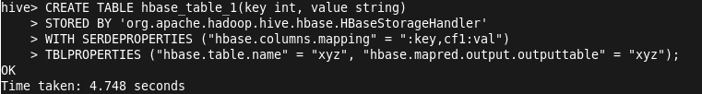

**Note- Here xyz is table name**

**2.To check table is create or not in hbase**

**1.hbase shell**

**2. list**

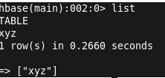

**3.scan table**

**C:\Users\viks\Desktop\h1.png**

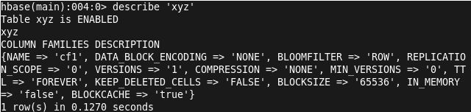

Notice that even though a column name "val" is specified in the mapping, only the column family name "cf1" appears in the DESCRIBE output in the HBase shell. This is because in HBase, only column families (not columns) are known in the table-level metadata; column names within a column family are only present at the per-row level.

**Create table in hive and load data on hbase table**

**create table emp(eid int,ename string)**

**row format delimited**

**fields terminated by ',';**

**load data local inpath '/home/cloudera/Desktop/emp' into table emp;**

**Then store result in hbase table**

**hive> insert overwrite table hbase_table_1 select * from emp;**

**C:\Users\viks\Desktop\h1.png**

**To see the result**

**scan 'xyz'**

